Gradient Descent: A Comprehensive Guide
Mathematical Foundations, Algorithms, and Optimization Techniques
An in-depth exploration of gradient descent optimization, covering mathematical principles, algorithm variants, convergence analysis, and practical applications in machine learning.
Autor: Generated by Moonshot AI / Kimi K2.5
February 2026

1. Introduction to Gradient Descent
Gradient descent is one of the most fundamental optimization algorithms in machine learning and deep learning. It is an iterative optimization algorithm used to find the minimum of a function, specifically the cost or loss function in machine learning models. The algorithm works by iteratively moving in the direction of steepest descent, defined by the negative of the gradient.The concept of gradient descent dates back to the 19th century, but it gained prominence with the rise of machine learning in the late 20th and early 21st centuries. Today, it serves as the backbone for training neural networks, linear regression, logistic regression, and many other machine learning algorithms.

1.1 What is Gradient Descent?
At its core, gradient descent is based on a simple intuition: to find the minimum of a function, we take steps proportional to the negative of the gradient of the function at the current point. The gradient points in the direction of the steepest ascent, so moving in the opposite direction leads us toward the minimum.The algorithm requires three essential components: (1) a differentiable cost function J(θ) that measures the error of the model, (2) initial parameter values θ, and (3) a learning rate α that controls the step size. The goal is to find the parameter values that minimize the cost function.
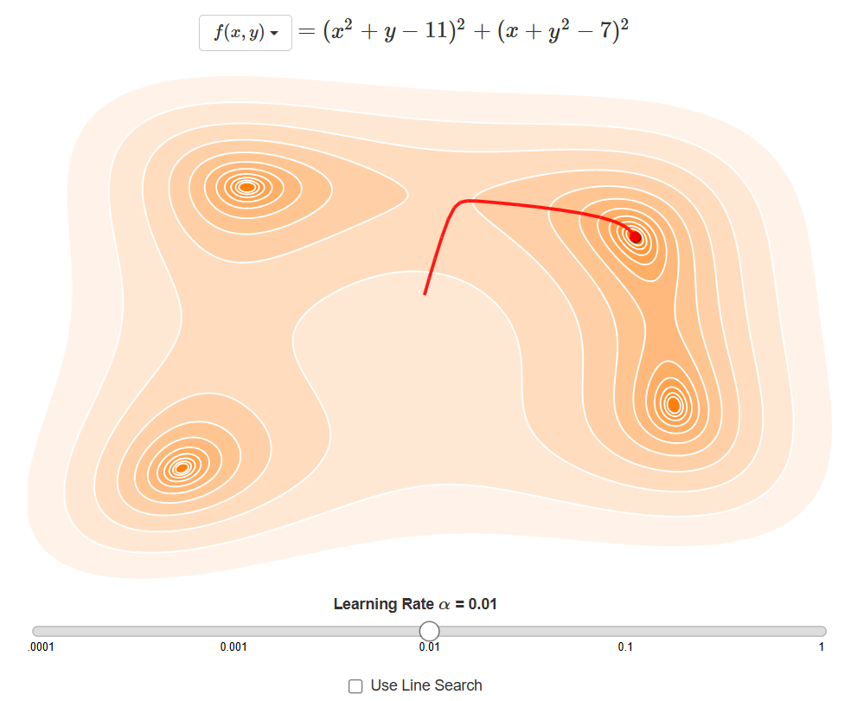
Figure 1: Gradient descent visualization showing iterative steps toward the minimum of a cost function

2. Mathematical Foundations
The mathematical foundation of gradient descent relies heavily on calculus, particularly derivatives and gradients. Understanding these concepts is crucial for comprehending how and why gradient descent works.

2.1 Derivatives and Rates of Change
A derivative measures the rate of change of a function with respect to its input. Geometrically, it represents the slope of the tangent line to the function at a given point. For a function f(x), the derivative f'(x) tells us how much f changes when x changes by an infinitesimal amount.The concept of derivatives is fundamental to optimization because they tell us which direction to move to decrease (or increase) a function. When the derivative is positive, the function is increasing; when negative, it is decreasing. At a minimum, the derivative equals zero.
$$\frac{df}{dx}=\lim_{h→0}\frac{f(x+h)-f(x)}{h}$$
Equation 1: Definition of the derivative as a limit
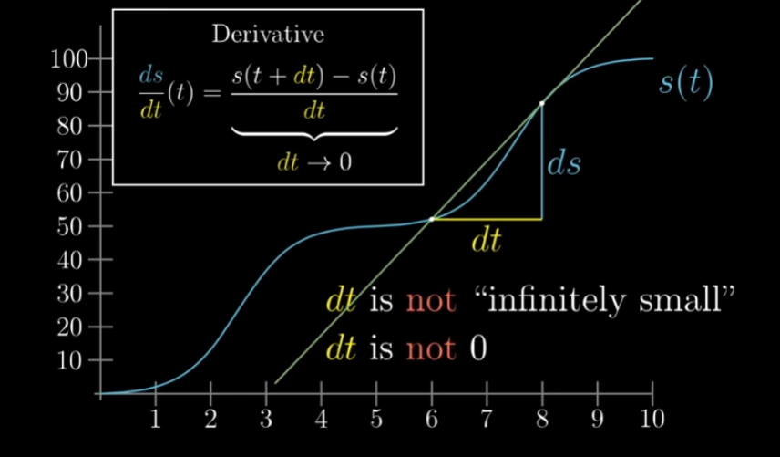
Figure 2: Mathematical definition of the derivative showing the limit as dt approaches zero
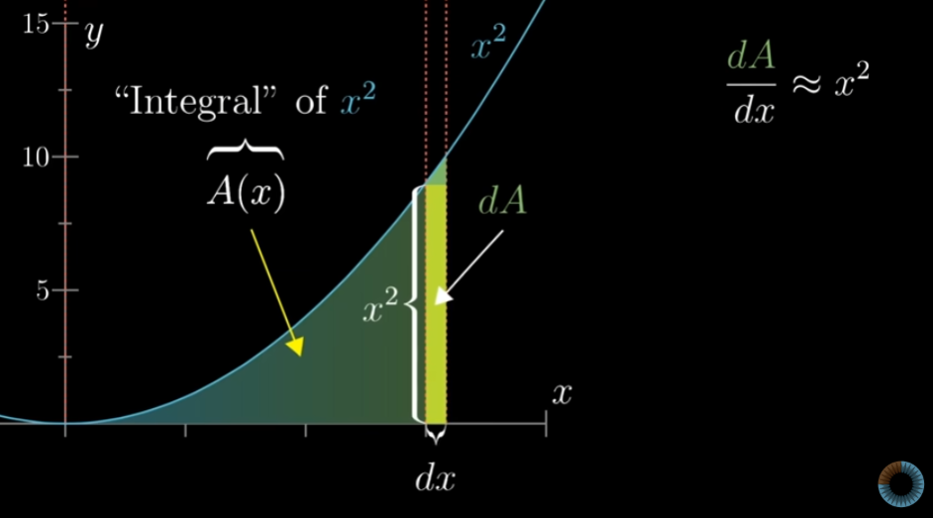
Figure 3: Geometric interpretation of derivatives and integrals showing area under curves

2.2 Partial Derivatives and Gradients
In multivariable calculus, we extend the concept of derivatives to partial derivatives. For a function f(x, y) of multiple variables, the partial derivative ∂f/∂x measures the rate of change in the x-direction while holding y constant. Similarly, ∂f/∂y measures change in the y-direction.The gradient, denoted ∇f, is a vector containing all partial derivatives of a function. For a function of n variables, the gradient is an n-dimensional vector pointing in the direction of the steepest ascent. This property makes the gradient invaluable for optimization.
$$∇f(x,y)=\left[\frac{∂f}{∂x},\frac{∂f}{∂y}\right]$$
Equation 2: Gradient vector for a two-variable function
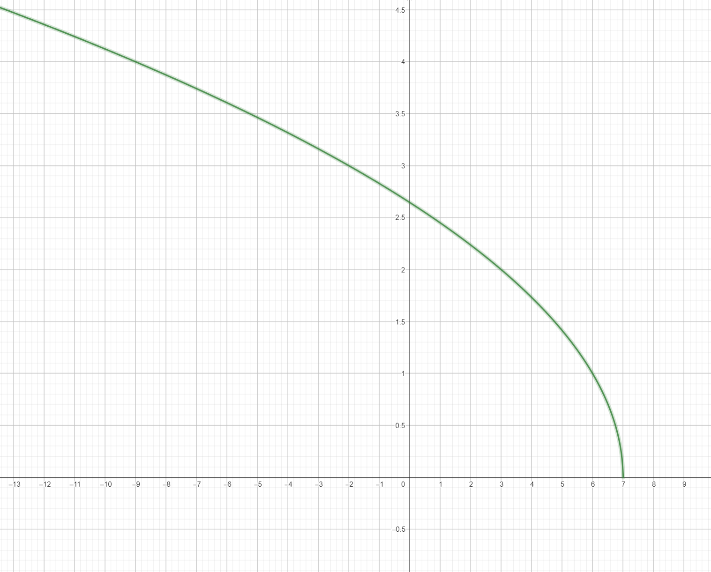
Figure 4: Domain visualization showing the relationship between a function and its domain D

2.3 The Gradient Vector
The gradient vector has two key properties: (1) it points in the direction of the greatest rate of increase of the function, and (2) its magnitude represents the slope or rate of increase in that direction. To minimize a function, we move in the opposite direction of the gradient.
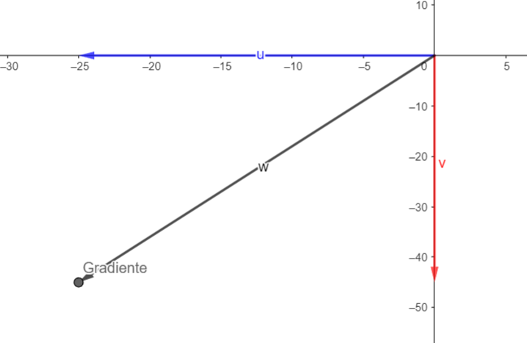
Figure 5: Gradient vector visualization showing the direction of steepest ascent

3. The Gradient Descent Algorithm
The gradient descent algorithm follows a straightforward iterative process. At each step, we compute the gradient of the cost function with respect to the parameters, then update the parameters by moving in the opposite direction of the gradient, scaled by the learning rate.This process continues until convergence, which occurs when the gradient becomes approximately zero (indicating we've reached a minimum) or when the change in parameters falls below a predefined threshold. The algorithm can be applied to any differentiable cost function.

3.1 Core Update Rule
$$θ_{new}=θ_{old}-α∇J(θ)$$
Equation 3: General gradient descent update rule
$$θ_{j}:=θ_{j}-α\frac{∂}{∂θ_{j}}J(θ)$$
Equation 4: Parameter update for the j-th parameter
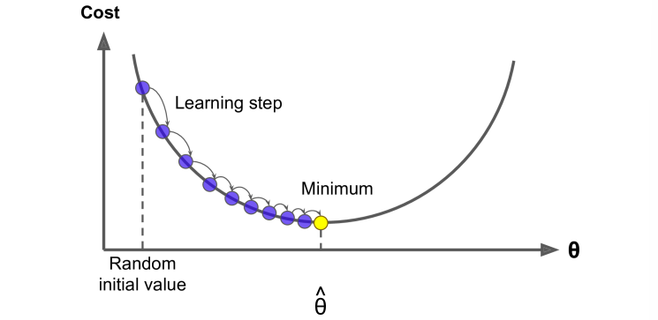
Figure 6: Gradient descent path showing learning steps from random initialization to minimum

3.2 Cost Function Visualization
The cost function in machine learning typically measures the difference between predicted and actual values. Common examples include Mean Squared Error (MSE) for regression and Cross-Entropy for classification. Visualizing the cost function helps understand the optimization landscape.In two dimensions, the cost function can be visualized as a surface or contour plot. The gradient descent algorithm traces a path down this surface toward the minimum. The shape of this surface—whether convex, concave, or containing multiple minima—greatly affects the algorithm's behavior.
$$J(θ)=\frac{1}{2m}\sum_{i=1}^{m}{(h_{θ}(x^{(i)})-y^{(i)})^{2}}$$
Equation 5: Mean Squared Error cost function
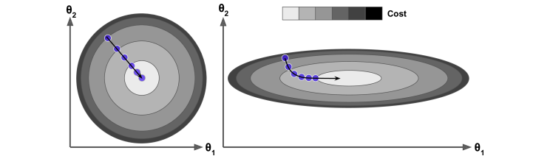
Figure 7: Contour plot showing gradient descent with two features (θ₁ and θ₂)

4. Types of Gradient Descent
There are three main variants of gradient descent, differing in how much data they use to compute the gradient at each step. Each variant offers different trade-offs between computational efficiency and convergence stability.
Table 1: Comparison of Gradient Descent Variants
Variant | Batch Size | Update Frequency | Memory Usage | Convergence Stability
Batch GD | All m examples | Per epoch | High (O(m)) | Very Stable
Stochastic GD | 1 example | Per example | Low (O(1)) | Noisy/Oscillating
Mini-Batch GD | b examples (32-512) | Per mini-batch | Medium (O(b)) | Moderately Stable

4.1 Batch Gradient Descent
Batch Gradient Descent uses the entire training dataset to compute the gradient at each iteration. This provides a stable, accurate estimate of the gradient but can be computationally expensive for large datasets. It guarantees convergence to the global minimum for convex functions.The main advantage of batch gradient descent is its stability—the gradient is computed exactly, leading to smooth convergence. However, for large datasets, computing the gradient over all examples at each step becomes prohibitively slow.
$$θ:=θ-α\frac{1}{m}\sum_{i=1}^{m}{(h_{θ}(x^{(i)})-y^{(i)})x^{(i)}}$$
Equation 6: Batch gradient descent update for linear regression
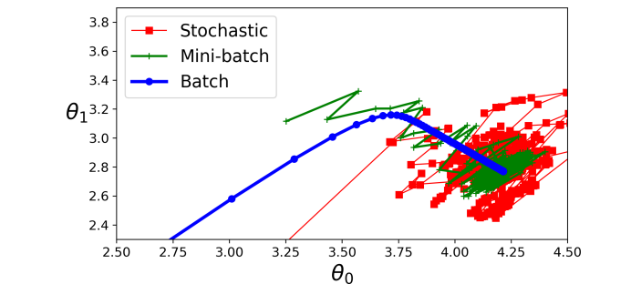
Figure 8: Comparison of Batch, Stochastic, and Mini-batch gradient descent convergence paths

4.2 Stochastic Gradient Descent (SGD)
Stochastic Gradient Descent updates parameters using only a single training example at each iteration. This makes it much faster per iteration and allows it to escape local minima more easily due to the noise in gradient estimates. However, this noise also causes the path to oscillate around the minimum.SGD is particularly useful for online learning and very large datasets where batch processing is impractical. The frequent updates provide detailed feedback on model performance, though the convergence path is less smooth than batch gradient descent.
$$θ:=θ-α(h_{θ}(x^{(i)})-y^{(i)})x^{(i)}$$
Equation 7: Stochastic gradient descent update rule
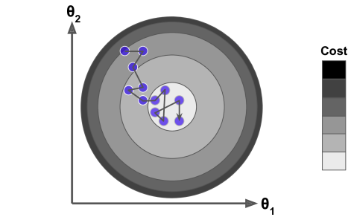
Figure 9: Stochastic gradient descent showing noisy but effective convergence

4.3 Mini-Batch Gradient Descent
Mini-Batch Gradient Descent strikes a balance between batch and stochastic methods. It uses a small batch of training examples (typically 32-512) to compute each gradient update. This approach combines the computational efficiency of SGD with the stability of batch gradient descent.Mini-batch is the most commonly used variant in practice, especially for training deep neural networks. It allows for vectorized operations that can be highly optimized on modern hardware like GPUs, while still providing relatively stable gradient estimates.
$$θ:=θ-α\frac{1}{b}\sum_{k=1}^{b}{(h_{θ}(x^{(k)})-y^{(k)})x^{(k)}}$$
Equation 8: Mini-batch gradient descent update

5. Learning Rate and Convergence
The learning rate is arguably the most important hyperparameter in gradient descent. It determines the size of the steps taken toward the minimum. Choosing an appropriate learning rate is crucial—too large, and the algorithm may overshoot the minimum; too small, and convergence becomes painfully slow.
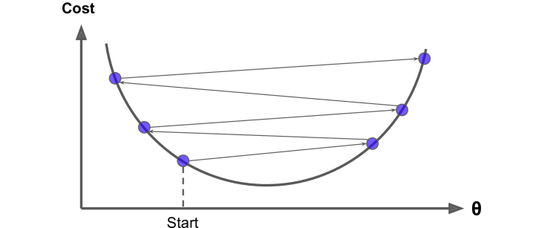
Figure 10: Effect of large learning rate causing oscillation and divergence
Various strategies exist for adapting the learning rate during training. Learning rate decay gradually reduces the learning rate over time, allowing for large initial steps and finer adjustments as the minimum is approached. More sophisticated methods like Adam and RMSprop adapt the learning rate per parameter.

5.1 Impact of Learning Rate
When the learning rate is too large, gradient descent may fail to converge, oscillating around the minimum or even diverging entirely. When too small, the algorithm may get stuck in local minima or plateaus, or simply take too long to reach convergence.The optimal learning rate depends on the specific problem, the cost function's curvature, and the dataset characteristics. Techniques like learning rate scheduling and adaptive learning rates help address these challenges automatically.
$$v_{t}=βv_{t-1}+(1-β)∇J(θ)$$
Equation 9: Momentum term calculation
$$θ:=θ-αv_{t}$$
Equation 10: Update with momentum
$$α_{t}=\frac{α_{0}}{1+γt}$$
Equation 11: Learning rate decay formula
Table 2: Impact of Learning Rate Selection
Learning Rate | Behavior | Risk | Best For
Too Small | Slow convergence | Getting stuck, long training | Fine-tuning near minimum
Optimal | Steady convergence | Requires tuning | General training
Too Large | Fast initial progress | Overshooting, divergence | Exploration phase
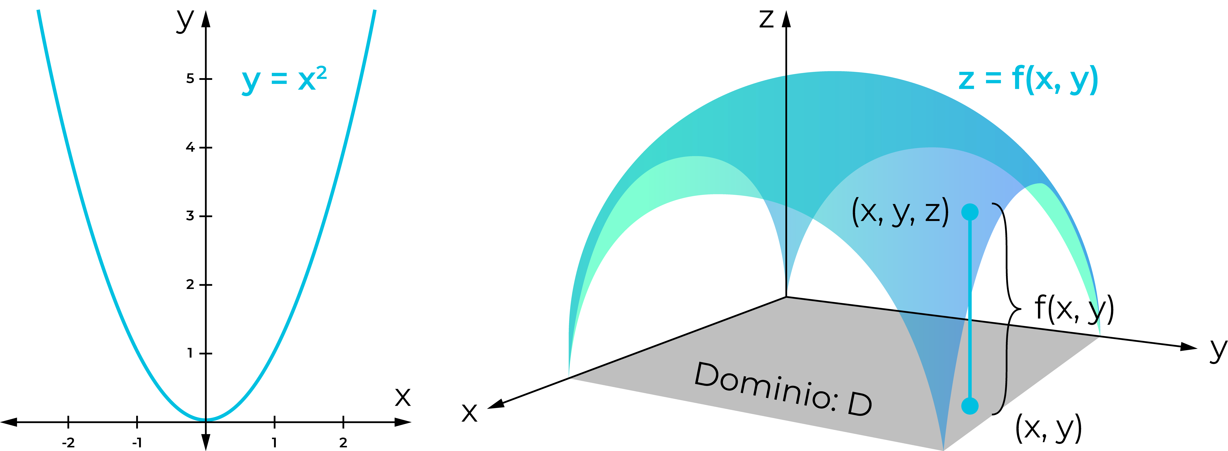
Figure 11: Himmelblau function showing gradient descent with learning rate α = 0.01

6. Challenges and Pitfalls
Despite its effectiveness, gradient descent faces several challenges that can impede convergence or lead to suboptimal solutions. Understanding these pitfalls is essential for successfully applying the algorithm.

6.1 Local Minima and Plateaus
Non-convex cost functions may contain multiple local minima, saddle points, and plateaus. Gradient descent can get trapped in local minima that are not globally optimal. Saddle points, where the gradient is zero but the point is neither a minimum nor maximum, can also slow convergence.Plateaus are flat regions where the gradient is nearly zero, causing the algorithm to make very slow progress. Momentum-based methods and adaptive learning rate algorithms help mitigate these issues by accumulating past gradients or adjusting step sizes dynamically.
Table 3: Common Gradient Descent Challenges
Challenge | Description | Solution
Local Minima | Algorithm converges to suboptimal minimum | Random restarts, momentum
Saddle Points | Gradient ≈ 0, but not at minimum | Second-order methods, noise
Plateaus | Flat regions with near-zero gradient | Adaptive learning rates
Overshooting | Steps too large, missing minimum | Learning rate decay
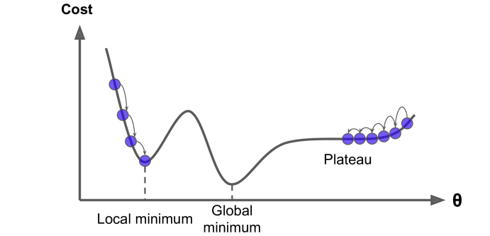
Figure 12: Common pitfalls including local minima, global minima, and plateaus
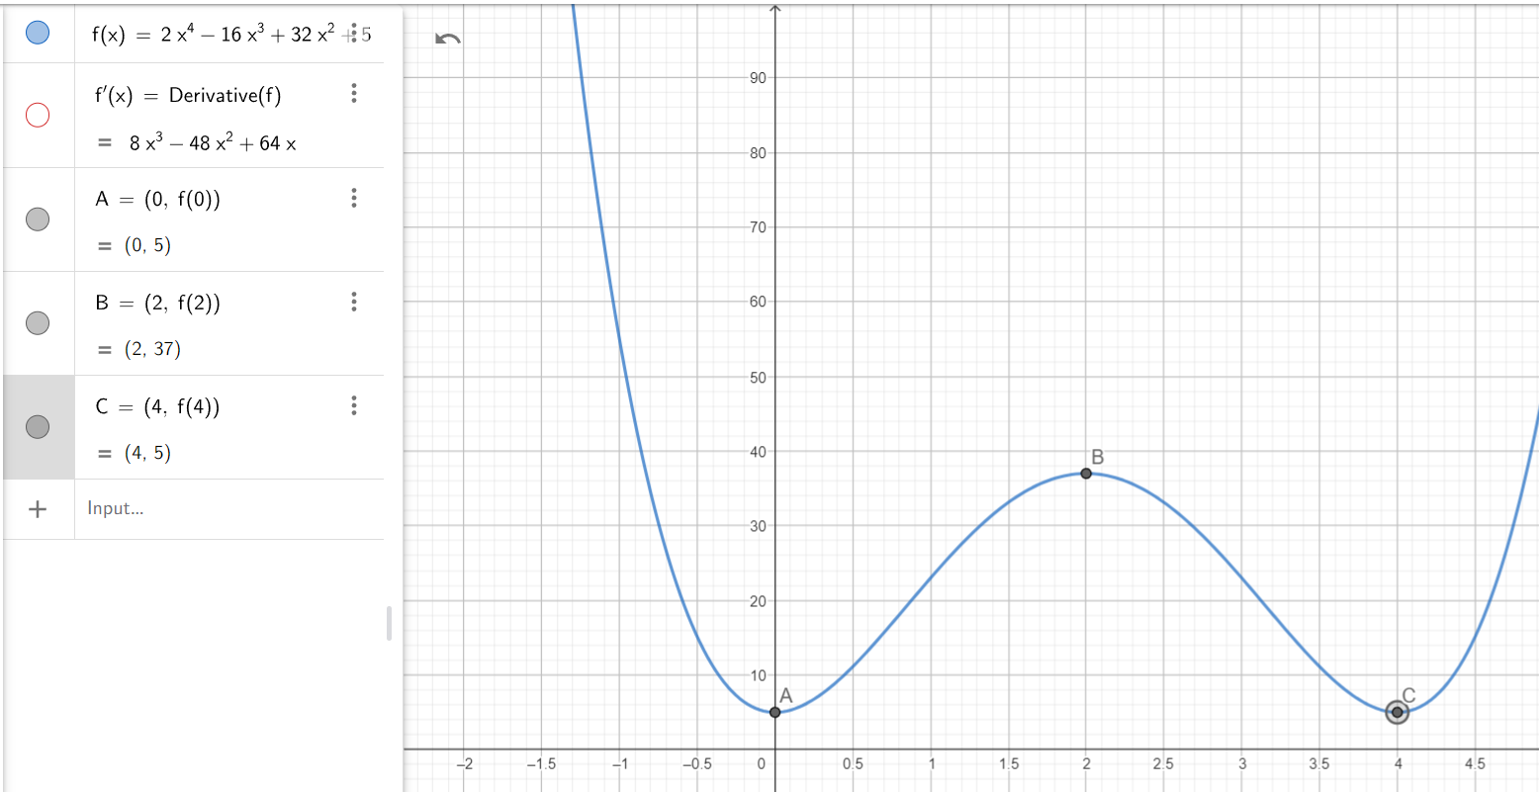
Figure 13: First derivative criterion for identifying critical points (minima, maxima, inflection)

7. Conclusion
Gradient descent remains a cornerstone of machine learning optimization. Its simplicity, versatility, and effectiveness make it indispensable for training models across diverse domains. Understanding its mathematical foundations, variants, and challenges enables practitioners to apply it effectively.As machine learning continues to evolve, gradient descent and its variants remain at the forefront. Advanced techniques like second-order methods, natural gradient, and meta-learning build upon these foundations, promising even more efficient optimization in the future.
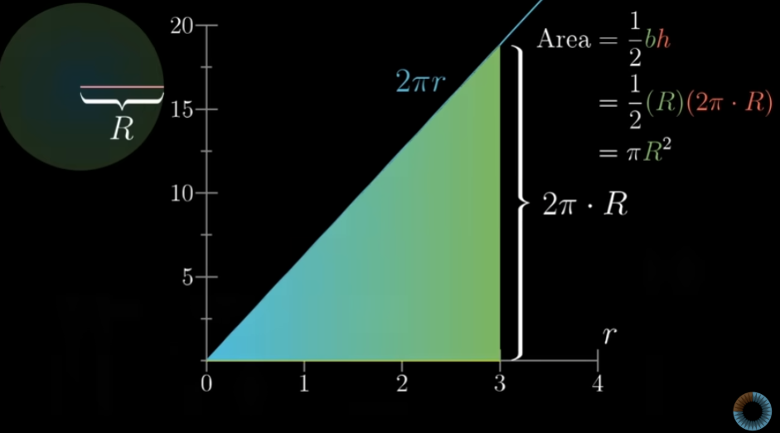
Figure 14: Area calculation using integration showing the fundamental theorem of calculus

